Personas, Site Structure, and Flow
Wade Eckert
Bellevue University
CSD 200: Foundations of Software Development
Professor Chandra Bobba
July 8, 2025

Personas, Site Structure, and Flow

Milestone 4 – Personas

1. Persona: Emily the Dog Mom
- Name: Emily Roberts
- Distinguishing Characteristics:
  - 32 years old
  - Lives in a suburban neighborhood
  - Works full-time remotely
  - Has a 2-year-old golden retriever named Max
  - Tech-savvy and highly organized
- Most Important Features:
  - Online appointment scheduling for grooming and boarding
  - User login and calendar view of appointments
- Least Important Features:
  - Pet adoption pages (already owns a pet)
- Needs to Meet:
  - Easily schedule grooming/boarding for Max without calling the store
  - Get reminders and view service history
- Computer Skill Level:
  - High – Comfortable navigating online platforms and mobile apps

2. Persona: Grandpa Joe
- Name: Joe Martinez
- Distinguishing Characteristics:
  - 68 years old
  - Retired, lives alone with his terrier, Daisy
  - Limited tech skills; prefers clear navigation
  - Visits the store weekly for supplies
  - Needs larger font sizes and accessibility features
- Most Important Features:
  - Store hours, service details, contact info
  - Ability to call directly from the website or request a callback
- Least Important Features:
  - Online shopping or user account creation
- Needs to Meet:
  - Simple access to store services
  - Assisted scheduling options or contact help
- Computer Skill Level:
  - Low – Needs clear buttons and fewer clicks

3. Persona: Jasmine the New Pet Parent
- Name: Jasmine Kim
- Distinguishing Characteristics:
  - 24 years old
  - Recently adopted a puppy and a kitten
  - Urban apartment dweller
  - Researches everything online
  - Loves browsing pet accessories and training tips
- Most Important Features:
  - Pet adoption info
  - Training service details and booking
  - Blog or tips for new pet owners
- Least Important Features:
  - Business hours (prefers digital scheduling)
- Needs to Meet:
  - Support and services for new pet parents
  - Easy-to-navigate service booking and learning center
- Computer Skill Level:
  - Moderate to High – Comfortable with e-commerce and interactive websites

Milestone 5 – Site Structure and Flow
A. Site Flow Diagram (Organization Chart Format)
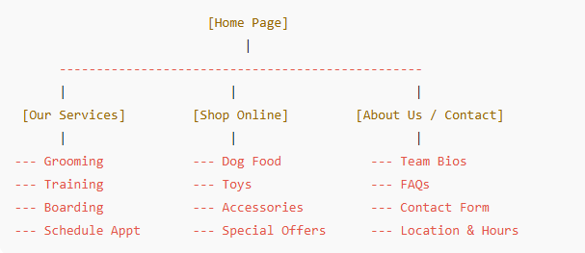
B. Text-Based Site Outline
- Home Page
  - Our Services
    - Grooming
    - Training
    - Boarding
    - Schedule Appointment
  - Shop Online
    - Dog Food
    - Toys
    - Accessories
    - Special Offers
  - About Us / Contact
    - Team Bios
    - FAQs
    - Contact Form
    - Location and Hours
C. Core Process Flow (UML Activity Diagram)
